**Chapter 3**

We look to software and cloud usage and their importance in the success of a firm competing in the film industry.

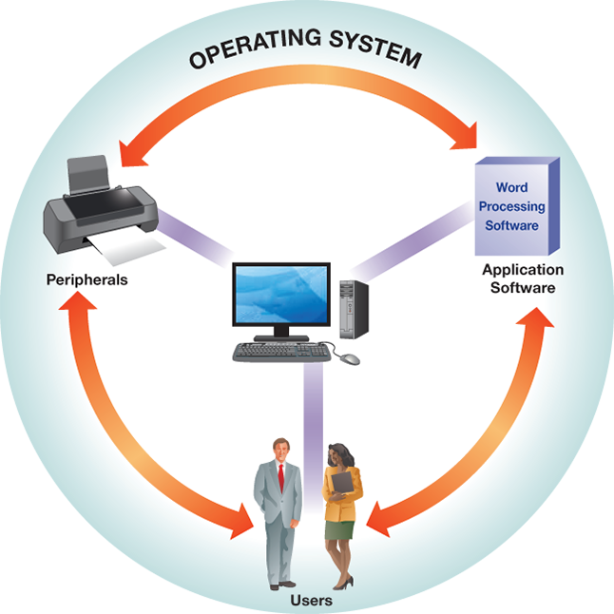

**System Software-** The harmony between the many different system software within a computer is what allows its users to accomplish their tasks so easily. This is apparent in the movie making process as well. Application software is necessary for movie editing because there are certain programs that deal exclusively with editing such as the Hollywood standard, Avid Media Composer1; Adobe Premiere; Final Cut; etc. Peripherals- such as a mouse or keyboard- are used extensively in the editing process to drag and drop the different clips and the keyboard being used for any editing shortcuts. The main player within system softwares is the operating system of the computer because this piece of software is in charge simplifying and executing commands from the user ranging from interpreting the input from the mouse or keyboard to storing the pieces of data that the user needs.

**Storage-** Storage has increasingly become more important in businesses because the government has made it mandatory for a business to archive any important documents and relevant internal communications through the Sarbanes-Oxley Act2 and it enables efficient storage and retrieval of data2. Throughout the stages of pre-production of a film, there is a level of collaboration between many different bodies of people that must maintain a schedule. This level of collaboration is accomplished with the efficient use of storage of plans, schedule, and distribution of said information to everyone working on the project to ensure that deadlines are met3. The necessity of storage and computing power also persists throughout the next step: the production process. These two are needed to keep any and all raw data of film- including the numerous different takes of different scenes- that will later be edited later in post-production and will need to be shared between different PCs in order to ensure that the movie can be worked on continuously3. Storage is then utilized in the post-production stage of the movie as the average production requires an average of six terabytes (Plus the amount of storage of any backup systems in place) to maintain high quality video and any subsequent edits made to it3.

**Cloud Computing-** In 2015, Netflix moved all of its data from being stored in data centers to the cloud.4 It has completely made the move to Amazon Web Services This is a financially smart move because the cost of having to maintain data centers is much greater than having its storage in the cloud. The utilization of of Amazon Web Services has yielded many benefits for its customers. AWS has allowed for flexibility as users have no need to contact their service provider first before accessing the cloud as well as the ability to have computing resources to be scaled up or down in an instant. The ubiquity of cloud services due to it being accessed from the internet means that users can access applications in the cloud can be accessed from any place at any moment and have its resources be pooled together and distributed to multiple customers rather than having a customer assigned to one specific, physical machine2. Cloud computing is revolutionizing the way that firms in the industry are conducting business while simultaneously allowing new ones to enter at a much cheaper price.

**Demand Fluctuations-** Movie theaters experience many fluctuations throughout the year. As big blockbusters are released nationwide, many theaters- and streaming services that have the movie available- can expect a surge of demand (Ticket purchases) and a subsequent slump afterwards.

***Citations***

1. Quora. (2019). What kind of software is used in film making in Hollywood? What kind of special software is being used for illustration, effects, montage, animation, etc.? Is Adobe one of the players?. [online] Available at: https://www.quora.com/What-kind-of-software-is-used-in-film-making-in-Hollywood-What-kind-of-special-software-is-being-used-for-illustration-effects-montage-animation-etc-Is-Adobe-one-of-the-players [Accessed 3 Mar. 2019].
2. VALACICH, J. (2017). INFORMATION SYSTEMS TODAY. 8th ed. [S.l.]: PRENTICE HALL, pp.102.
3. Olmsted, E. (2019). Information Technology and the Movie Making Process. [online] Ols.technology. Available at: https://www.ols.technology/newsletter-content/information-technology-and-the-movie-making-process [Accessed 3 Mar. 2019].
4. Chernicoff, D. (2019). Netflix closes data centers and goes to public cloud. [online] Datacenterdynamics.com. Available at: https://www.datacenterdynamics.com/news/netflix-closes-data-centers-and-goes-to-public-cloud/ [Accessed 5 Mar. 2019].